IP Address
In networking, an IP address (Internet Protocol address) is like a digital address assigned to each device connected to a computer network. It serves two main purposes: identifying the host or network interface and providing a location address for communication.
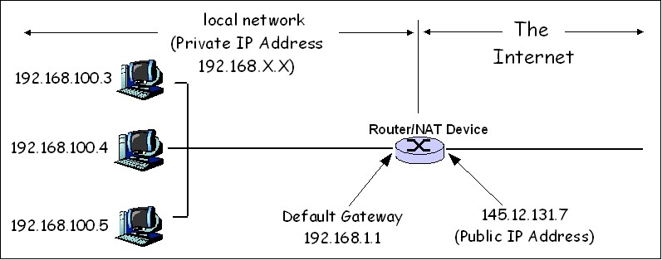
IP Address

Example:
Imagine you have a home network with two devices - a computer and a mobile. Each device needs an IP address to communicate within the network. Let's assign IP addresses to these devices:
- Computer: 192.168.1.2
- Mobile: 192.168.1.3
In this example:
- 192.168.1.2 is the IP address of the computer.
- 192.168.1.3 is the IP address of the Mobile.

Breaking Down the IP Address:
- 192.168.1: This part of the address represents the network. Devices with similar network numbers can communicate directly with each other within the same network.
- .2 and .3: These last parts of the address identify each specific device within the network. Each device on the network must have a unique number.
In summary, an IP address is like a digital label for devices in a network, helping them find and talk to each other. Just as your home has a unique address, each device on a network has a unique IP address for effective communication.

Subnet
In networking, a subnet (short for subnetwork) is a way to divide a larger network into smaller, more manageable segments. This segmentation helps in organizing and efficiently using IP addresses within a network.
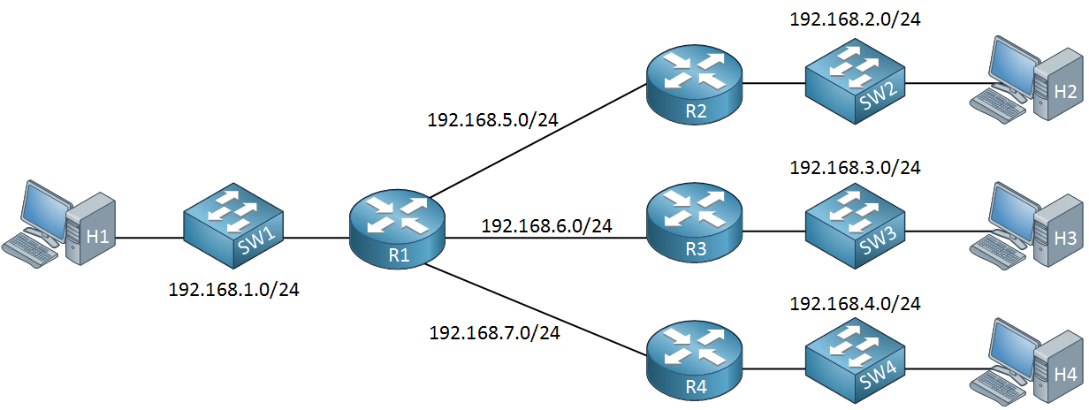
Networking Subnet

Explanation:
- IP Address: An IP address is like a home address for devices on a network, allowing them to communicate with each other. For example, an IP address could be 192.168.1.1.
- Subnetting: Subnetting involves dividing the IP address space of a network into smaller parts or subnets. This is particularly useful for large networks where efficient management of IP addresses is essential.
- Subnet Mask: A subnet is defined by a subnet mask, which is a set of numbers that separates the network and host portions of an IP address. It's like a filter that helps routers and devices understand which part of the IP address belongs to the network and which part identifies a specific device within that network.
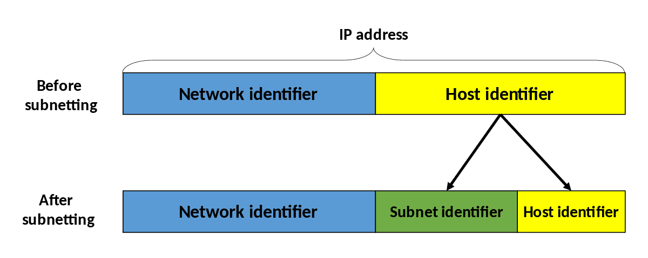
Subnet Masking

Example:
- Original IP Address: 192.168.1.1
- Original Subnet Mask: 255.255.255.0
In this example, the original IP address is in the network "192.168.1.1," and the subnet mask "255.255.255.0" divides it into network and host portions:
- Network Portion: 192.168.1
- Host Portion: 1
Now, let's subnet further to create smaller subnetworks. If we change the subnet mask to "255.255.255.128," it creates two subnets:
- Subnet 1:Network Portion: 192.168.1Host Range: 0 to 127
- Subnet 2:Network Portion: 192.168.1Host Range: 128 to 255
By subnetting, we've effectively divided the original network into two smaller subnetworks, each capable of accommodating devices within its specified range.
In summary, subnetting is a way to logically divide a larger network into smaller, more manageable parts, optimizing the use of IP addresses and enhancing overall network efficiency.

2.1 Subnet Range: Why only 0 to 255?
In networking, when we talk about a subnet's range from 0 to 255, we're referring to the possible values that can be assigned to the last part of an IPv4 address, which is called an octet.
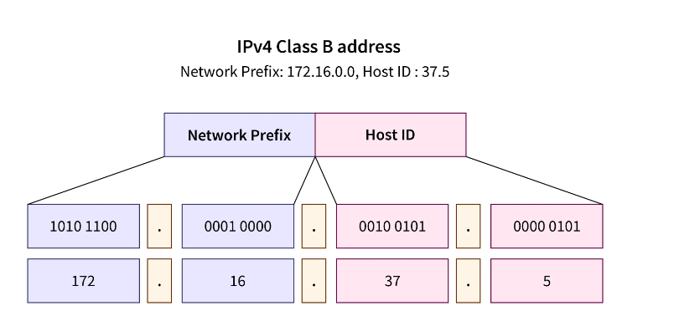
Subnet Range

Explanation:
IPv4 Address Format:
- An IPv4 address is made up of four parts, called octets, separated by dots. Each octet is represented by a number ranging from 0 to 255.
Example IPv4 Address:
- Consider the IPv4 address: 192.168.1.1
Subnet Range:
- The range from 0 to 255 refers to the possible values that can be assigned to the last octet of an IPv4 address. This last octet is often used to identify individual devices within a network.
Example:
Original IPv4 Address: 192.168.1.1
Now, let's explore the possible values for the last octet:
1. If the last octet can take values from 0 to 255:
- 192.168.1.0, 192.168.1.1, 192.168.1.2, ..., 192.168.1.255
This means that any device within the network could potentially have an IP address where the last octet is any number from 0 to 255.

Why 0 to 255?
Binary Representation:
- In binary (base-2), an octet can represent values from 00000000 to 11111111. This is equivalent to 0 to 255 in decimal (base-10).

Flexibility:
- Allowing values from 0 to 255 provides flexibility in addressing, allowing for a large number of unique addresses within a network.
Example Scenario:
Let's say you have a network with the base IP address "192.168.1" (the first three octets), and you want to assign unique addresses to devices within that network:
- Device 1: 192.168.1.10
- Device 2: 192.168.1.20
- Device 3: 192.168.1.30
- ...
- Device 255: 192.168.1.255
Each device within the network can have a unique address by varying the last octet from 0 to 255.
In summary, the range from 0 to 255 for the last octet in an IPv4 address provides a wide range of unique addresses that can be assigned to devices within a network, allowing for flexibility and scalability in networking.

CIDR
CIDR, which stands for Classless Inter-Domain Routing, is a method used in networking to efficiently allocate and manage IP addresses. CIDR notation represents an IP address and its associated routing prefix.
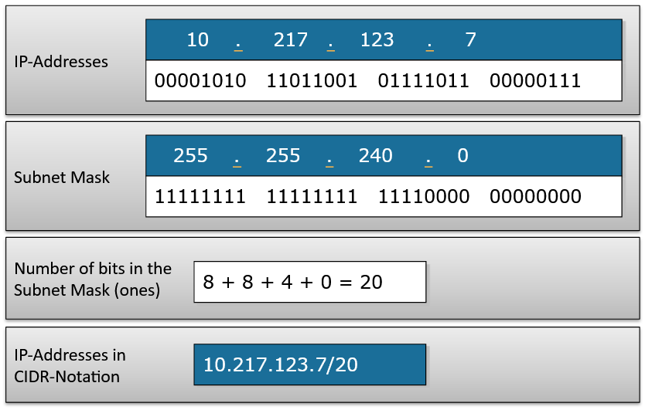
CIDR notation Example
Explanation:
- IPv4 Address:
An IPv4 address is made up of four parts, called octets, separated by dots. Each octet is represented by a number ranging from 0 to 255.
- CIDR Notation:
CIDR notation combines the IP address with a forward slash (/) and a number representing the length of the network prefix.
- Example IPv4 Address:
Consider the IPv4 address: 192.168.1.1
Example:
- Original IPv4 Address: 192.168.1.1
Now, let's represent this address using CIDR notation:
- CIDR Notation: 192.168.1.1/24
In this example, "/24" indicates that the first 24 bits of the IPv4 address are the network prefix, and the remaining 8 bits are available for host addresses within that network.

Breaking it Down:
- Binary Representation: In binary (base-2), the IPv4 address 192.168.1.1 is represented as:
11000000.10101000.00000001.00000001
The "/24" in CIDR notation means that the first 24 bits are designated as the network prefix.
- Network Prefix:
The network prefix identifies the common part of the IP addresses within a network. In this case, the network prefix is "11000000.10101000.00000001."
- Host Addresses:
The remaining 8 bits (32 total bits - 24 bits for the network prefix) are available for host addresses. This allows for 2^8 = 256 unique host addresses within the network.

CIDR Notation in Action:
If we want to represent a range of IP addresses within this network, we can use CIDR notation:
- CIDR Notation for Range: 192.168.1.0/24
This represents all IP addresses from 192.168.1.0 to 192.168.1.255, where the first 24 bits are the common network prefix.

Why CIDR?
CIDR allows for efficient utilization of IP address space by aggregating multiple IP addresses under a common network prefix. It simplifies routing and helps minimize the number of routing table entries in large-scale networks.
In summary, CIDR notation combines an IP address with a prefix length to represent a range of addresses within a network, allowing for efficient allocation and management of IP addresses.

Types of Subnets in Networking
In networking, subnets are created by dividing a larger network into smaller, more manageable segments. These subnets help in efficient address allocation and organization. Let's explore two common types of subnets: Public Subnet and Private Subnet, using a simple example:
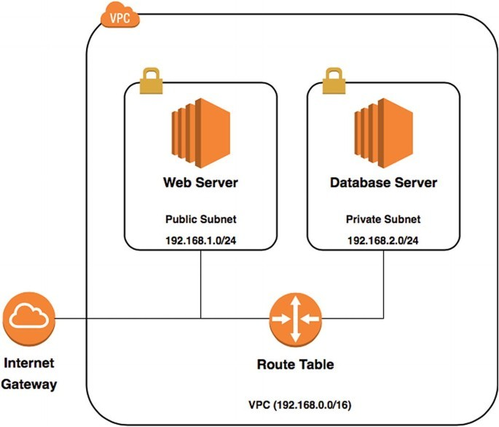

Public Subnet:
Explanation:
A public subnet is a segment of a network with IP addresses that are publicly routable on the internet. Devices in a public subnet can be accessed directly from the internet.
Example:
Suppose you have a public-facing web server. You assign it a public IP address within a public subnet. Users on the internet can access this server directly.
Public Subnet: 203.0.113.0/24

Web Server: 203.0.113.10
- Here, "203.0.113.0/24" is the public subnet, and "203.0.113.10" is the public IP address assigned to the web server.

Private Subnet:
Explanation:
A private subnet is a segment of a network with IP addresses that are not directly accessible from the internet. Devices in a private subnet are typically shielded from direct exposure for security reasons.
Example:
Let's say you have a database server that should not be directly accessed from the internet. You assign it a private IP address within a private subnet.
Private Subnet: 192.168.1.0/24

Database Server: 192.168.1.10
- Here, "192.168.1.0/24" is the private subnet, and "192.168.1.10" is the private IP address assigned to the database server.
Why Use Both?
- Security:
Public subnets expose services to the internet, while private subnets keep sensitive services, like databases, shielded from direct exposure.
- Flexibility:
Having both types of subnets allows for a flexible and secure network architecture. You can control which services are accessible from the internet and which are kept internal.
Putting it Together:
In a larger network scenario, you might have multiple subnets for different purposes, such as public-facing services, internal applications, or secure back-end systems. Each subnet type serves a specific role in creating a well-organized and secure network architecture.
In summary, public subnets are used for services that need direct internet access, while private subnets are used for internal services that require an additional layer of security. The combination of both types allows for a balanced and secure network design.

VPC in networking
In networking, a VPC (Virtual Private Cloud) is a virtualized network infrastructure that allows you to create isolated and customizable network environments within a cloud service provider's data center. Let's break down the concept of VPC with a simple example:
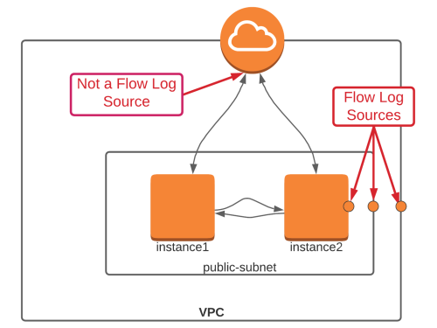
VPC with Public Subnet having 2 Isolated Instances

Explanation:
- Cloud Service Provider:
Cloud service providers, such as Amazon Web Services (AWS) or Microsoft Azure, offer virtualized infrastructure services. A VPC is a feature provided by these cloud providers.
- Isolated Networking Environment:
A VPC creates a logically isolated section of the cloud where you can launch and run resources like virtual servers, storage, and databases.
Simple Example:
Let's consider an analogy with a large office building:
- Physical Building:
Imagine a huge office building that represents the entire cloud infrastructure.
- Office Floors:
Now, within this building, you want to create isolated office floors for different departments. Each floor is like a separate VPC.
- Security and Separation:
Each department (VPC) has its own offices, meeting rooms, and resources. They are isolated from each other for security and privacy reasons.
- Customization:
Each department can customize its office space based on its specific needs. Similarly, each VPC can be configured with its own set of rules, security settings, and networking options.
Key Features of a VPC:
1. Isolation:
VPCs provide isolation, ensuring that resources within one VPC are separate from those in another. This is similar to different departments working independently in the analogy.
2. Customization:
You can configure and customize the settings of each VPC according to your specific requirements. For example, you can set up different networking rules and security protocols.
3. Resource Launching:
Within each VPC, you can launch virtual servers, databases, and other resources. These resources operate within the confines of the VPC, similar to how each department operates within its designated floor.
Real-world Cloud Scenario:
In the cloud context:
- Cloud Infrastructure:
The entire cloud infrastructure (AWS, Azure, etc.) is like the big office building.
- VPCs:
Each VPC is like a separate floor within the building, representing an isolated network environment.
- Departments/Resources:
Resources like virtual servers, storage, and databases are analogous to offices and meeting rooms within each department (VPC).
By using VPCs, you achieve flexibility, security, and efficient resource management within the cloud environment, just as different departments operate independently within a large office building.

Port
In networking, a port is a communication endpoint used by software to identify a specific process or service running on a device. Ports allow multiple applications to operate simultaneously on a single device, each using its own designated port number.
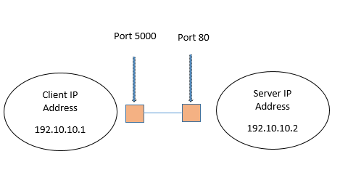

Ports for Client and Server

Here's a brief explanation of ports with examples:
1. Port Numbers: Ports are identified by numbers ranging from 0 to 65535. Ports from 0 to 1023 are well-known ports, reserved for specific services like HTTP (port 80), HTTPS (port 443), FTP (port 21), SSH (port 22), etc. Ports from 1024 to 49151 are registered ports used by user applications, while ports from 49152 to 65535 are dynamic or private ports.
2. TCP and UDP Ports: Ports are associated with either TCP (Transmission Control Protocol) or UDP (User Datagram Protocol). TCP is connection-oriented, providing reliable data transmission, while UDP is connectionless and provides faster but less reliable data transmission.
3. Example: Consider a web server hosting a website. When a client requests a webpage, it sends an HTTP request to the server. The server listens for incoming HTTP requests on port 80 (default for HTTP). Once the request arrives, the server processes it and sends back the requested webpage through port 80 to the client.
4. Another Example: In online gaming, players connect to game servers using specific ports. For instance, a game might use UDP port 7777 for gameplay data and TCP port 7778 for administrative tasks. Players' game clients communicate with the server through these designated ports to send and receive game data.
In summary, ports play a crucial role in facilitating communication between devices over a network, allowing multiple services to run simultaneously and ensuring that data reaches the intended applications or processes.

OSI Model
The OSI (Open Systems Interconnection) model is a conceptual framework used to understand and standardize the functions of a telecommunication or computing system. It consists of seven layers, each responsible for specific tasks in facilitating communication between devices on a network. Here's a detailed explanation of each layer along with examples from day-to-day life:
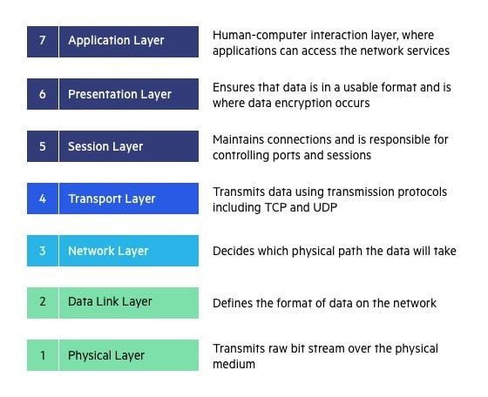

1. Physical Layer (Layer 1):
- The physical layer deals with the transmission and reception of raw data bits over a physical medium, such as wires, cables, or wireless signals.
# Example: Physical Layer Interaction
def transmit_data(signal):
# Converts data into electrical, optical, or radio signals
return converted_signal
- Example: Ethernet cables, Wi-Fi signals, fiber optic cables.
2. Data Link Layer (Layer 2):
- The data link layer handles the framing, error detection, and correction of data packets.
- It ensures reliable point-to-point and point-to-multipoint communication.
# Example: Frame Processing in Data Link Layer
def process_frame(frame):
# Check for errors in the frame
if error_detected(frame):
request_resend()
else:
forward_to_next_layer(frame)
- Example: Ethernet switches, MAC addresses.
3. Network Layer (Layer 3):
- The network layer is responsible for routing packets across different networks and determining the optimal path for data transmission.
- It provides logical addressing and handles packet forwarding.
# Example: Routing Functionality in Network Layer
def route_packet(packet, destination):
# Determine the best path for packet
return best_route
- Example: IP (Internet Protocol), routers.
4. Transport Layer (Layer 4):
- The transport layer ensures end-to-end communication between devices and provides error recovery and flow control mechanisms.
- It segments and reassembles data into manageable chunks.
# Example: TCP Connection Handling
def establish_tcp_connection():
# Set up a reliable connection
return connection_established
- Example: TCP (Transmission Control Protocol), UDP (User Datagram Protocol).
5. Session Layer (Layer 5):
- The session layer establishes, manages, and terminates communication sessions between devices.
- It provides services such as session checkpointing and recovery.
# Example: Session Management
def manage_session():
# Handle session establishment, maintenance, and termination
return session_status
- Example: NetBIOS (Network Basic Input/Output System), RPC (Remote Procedure Call).
6. Presentation Layer (Layer 6):
- The presentation layer translates, encrypts, or compresses data for efficient transmission.
- It ensures that data exchanged between applications is in a format that each understands.
# Example: Data Translation
def translate_data(data):
# Convert data to a suitable format
return formatted_data
- Example: Encryption, data compression, ASCII (American Standard Code for Information Interchange).
7. Application Layer (Layer 7):
- The application layer enables user interaction with the network and provides network services directly to end-users.
- It includes protocols and applications for tasks such as file transfer, email, and web browsing.
# Example: Application Layer Protocol
def access_network_resources():
# Interface with network resources
return resource_access
- Example: HTTP (Hypertext Transfer Protocol), SMTP (Simple Mail Transfer Protocol), FTP (File Transfer Protocol).
Example in Day-to-Day Life:
Consider sending an email from one computer to another:
- The application layer involves your email client (e.g., Outlook, Gmail).
- The presentation layer may encrypt the email content to ensure security.
- The session layer establishes a session between your email client and the email server.
- The transport layer segments the email into packets and ensures reliable delivery using TCP.
- The network layer routes the packets across the Internet using IP addresses.
- The data link layer packages the packets into frames for transmission over Ethernet.
- The physical layer transmits the frames as electrical signals over wires or as radio waves over Wi-Fi.
Understanding the OSI model helps network engineers and developers troubleshoot issues, design networks, and develop compatible communication protocols.

